# **Information Visualization**

# **CHECKPOINT III: Visualization Sketch**

G22 - A

**1. Overview**

In our visualization we are going to present the average amount of money needed to travel to each country in the world depending of several factors. In addition, we will gather data of all countries in order to compare them.

Therefore, we will use the following idioms to embody our visualization:

* Choropleth Map (with Pins), which will display the divided geographical areas that will be colored/shaded in relation to the average price to travel to. Darker color represents the most expensive country(ies) and the lighter color will symbolize the cheapest country(ies), the countries with the price between will have colors within the chosen color spectrum range. When the user manually selects a country or a set of countries, the map will display a pin on each one.
* Bar Chart, showing comparisons among the different countries selected. The XX axis of the chart shows the defined countries, and the YY axis represents the average prices. If there are countries selected in the map, those will be the ones presented, if not, it will be displayed the cheapest ones taking into consideration the categories selected in the checkboxes.
* Floating Bars, representing the total price to travel to the selected country divided per categories (accommodation, food, transportation, entertainment, alcohol and shopping) as a set of vertical bars. One axis of the chart shows the categories, and the other axis represents the average prices. There will be a drop-down with the countries that the user selected in the map. If there are no countries selected in the map it will be shown by default the 5 cheapest ones.
* Dot Plots, consisting of data points plotted on a scale, typically using filled in circles which will correspond to sub-categories of our main categories’ food and accommodation.

To do this we will have several types of inputs for different purposes:

* Input for the time duration of the trip, by default this value will be one day.
* Input for the total budget, when filled this will set a limit to the cost of the trip according to the duration previously set. By default, it will be shown in every idiom the rank from the most expensive to the least. Countries that have costs higher than the defined budget will be grayed out.
* Checkboxes with the various filters (accommodation, food, transportation, entertainment, alcohol and shopping) that will be considered. By default, all filters are unselected.
* Range slider representing each category (accommodation, food, transportation, entertainment, alcohol and shopping). This will allow the user to define exactly how much he want to spend in each category. This will only be allowed if its category is selected in the checkboxes.

**2. Visual Encoding**

We will have 2 types of data:

* Country which is a Nominal type and will be represented in our visualization by the position in the map and the tag of each bar.
* Price which is a quantitative type and will be represented by the size of each bar and also by the tags charts.

**3. Idiom and Tasks/Questions**

* Which are the cheapest countries regarding accommodation?

By selecting the checkbox regarding accommodation, in the Bar chart it will be shown the top 5 cheapest countries to travel regarding accommodation. So, to find out the cheapest country, the user just needs to see what the country is corresponding to the lowest bar in the graph.

* Which are the cheapest countries regarding transportation and alcohol?

By selecting the checkbox regarding transportation and alcohol, in the Bar chart it will be shown the top 5 cheapest countries to travel regarding these filters. So, to find out the cheapest countries, the user just needs to see what the country is corresponding to the lowest bar in the graph.

* Which are the countries we can travel to with a maximum budget of 600€/4 nights?

The user defines the respective values of the number of nights to four and the maximum budget to 600€ and in the map it only appears shaded the countries which respects those boundaries.

* How much is the average cost of food in Hungary?

The user selects in the map Hungary and in the floating bar it can be seen the average cost of each category including food. Furthermore, in the dot chart it is also visible the costs of eating in a cheap vs expensive place.

* Given a maximum budget of 1000€/7 nights, we select 200€ for accommodation and 300€ for food. Which are the countries that match these parameters?

The user defines the respective values of the number of nights to seven and the maximum budget to 1000€. Drags the range slider corresponding of accommodation to 200€ and the food one to 300€. In the map it only appears shaded the countries which respects those boundaries.

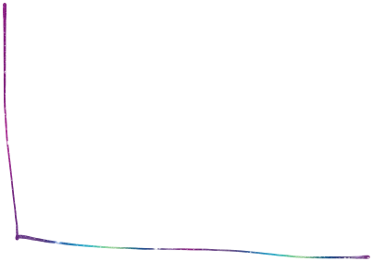

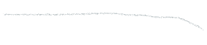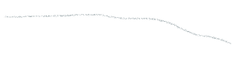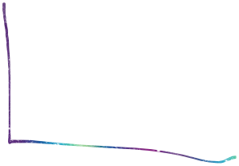

Cada conjunto de bolas é um subtipo ou subcategoria da categoria (acc e food)